39.Design DFA using simulator to accept the string the end with abc over set {a,b,c)

W= abbaababc

*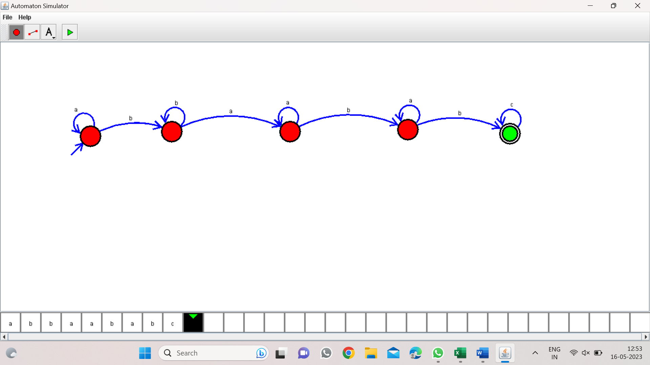*

*Result:-*

*From the above DFA diagram valid the input string abbaababc and end with abc*